**Unemployment 2005 to 2015**

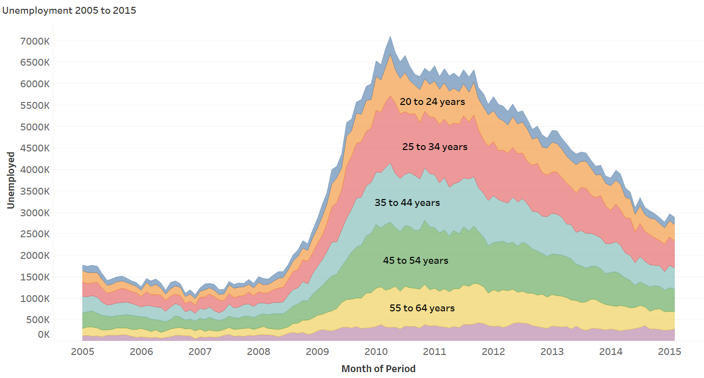

**Unemployment 2005 to 2015 (Men)**

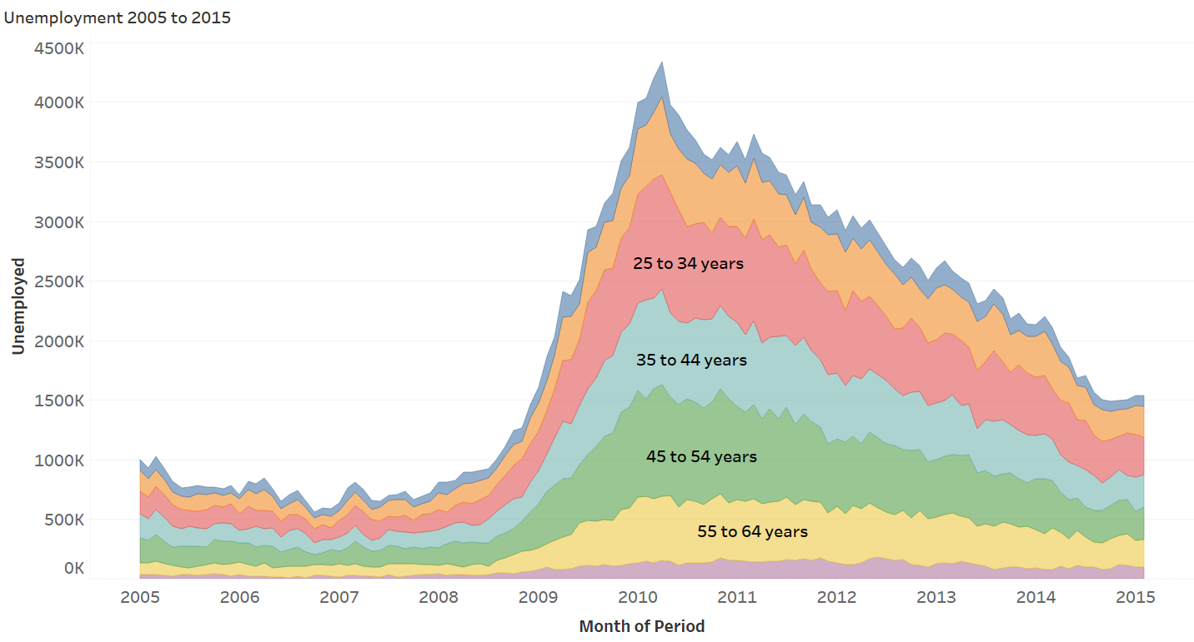

**Unemployment 2005 to 2015 (Women)**

